ReactJS
Introducing ReactJS
Gerry Byrne
David Wilson

Version 1.0


Amendment Record Sheet

Version No. | Date | Amendment Description | Amended By | Approved By
1.0 | 12 June 2016 | Approved document | Gerry Byrne | David Wilson

Topic Overview

This topic will introduce the use of the ReactJS JavaScript library for providing a view for data rendered as HTML. The view is what we also call our UI.

React views are typically rendered using components that contain additional components specified as custom HTML tags. React gives programmers:
- a model in which subcomponents cannot directly affect enclosing components ("data flows down")
- efficient updating of the HTML document when data changes and
- a clean separation between components on a modern single-page application.
This course will introduce you to the ReactJS library and the associated JSX language and give you the skills to develop different applications.

Topic Objectives

At the end of this topic you will be able to:

- Reference the React framework from a CDN
- Use the React framework
- Use components
- Use properties
- Use Events
- Use state

Contents
What is ReactJS? 5
Is React a framework? 5
DOM and Virtual DOM 6
DOM 6
Issues associated with the DOM 6
Virtual DOM 7
Reasons to use ReactJS 9
Tools required 10
Text editor 10
Browser 10
Server 10
JSFiddle 10
ReactJS Starter kit 11
JSX 11
Babel 12
Exercise One – Basic Component returning HTML 13
Lab One – Basic Component returning HTML 18
Exercise Two – Basic Component returning HTML 21
Exercise Three – Multiples components and properties 24
Exercise Four – Multiples components and properties (props) 29
Exercise Five – Events 33
Exercise Six – State 38
Exercise Seven – Adding state to components 42
Exercise Eight – Using Refs 48
Exercise Nine – Using Multiple Child Components 54

What is ReactJS?
ReactJS is also known as React.js and is an open-source JavaScript library which provides a view for data rendered as HTML. It may be thought of as the V in the MVC. Some will say React is a front-end JavaScript framework.
React views are typically rendered using components that contain additional components specified as custom HTML tags. React gives programmers:
- a model in which subcomponents cannot directly affect enclosing components ("data flows down")
- efficient updating of the HTML document when data changes and
- a clean separation between components on a modern single-page application

React was first developed at Facebook and when Instagram joined the company, the team began to look for ready-made tools to build the Instagram web app. Consequently, Facebook’s team made ReactJS open source and share the React framework. The ReactJS library is maintained a community of developers and businesses including Facebook and Instagram. There is also React Native which allows native iOS and Android development with React.

Is React a framework?
No, ReactJS is not a framework, as we stated earlier ReactJS is the "View" in the application. The V in MVC and we must add it is a fast view. ReactJS provides us as developer’s different ways to organise our templates and is intent on getting us to think in components. In a ReactJS application it is important that we break down our site, page or feature into smaller pieces of components. ReactJS is therefore getting us to us a modular approach in which our site will be built by the combination of different components. In turn each component is built on the top of other components and so on. As developers we know that when we have a business problem we need to break it down into smaller parts and then resolve the smaller parts. When we break the problem into smaller parts we are trying to see if we can reuse the parts elsewhere (like developing methods and reusing them). We can think of this as component-driven development.

DOM and Virtual DOM
React uses a concept called the virtual DOM which makes the rendering extremely fast but still keeps it easily understandable and controllable. We can combine this with the idea of components and have the power of top-down rendering.

DOM
The acronym DOM stands for Document Object Model and is an abstraction of a structured text. As developers or web developers we see this text as HTML code and the DOM is simply called the HTML DOM. Elements of HTML become nodes in the DOM. Whilst HTML is actual text the DOM is an in-memory representation of this text.
We could compare this to a process being an instance of a program. As we are aware we can have multiple processes of the same one program in the same way we can have multiple DOMs of the same HTML e.g. we can have the same page loaded in many tabs.
The HTML DOM provides an interface, an application programming interface, to traverse and modify the nodes. It contains methods like getElementById or removeChild and we probably use JavaScript to work with the DOM. An example would be when we want to dynamically change the content of the web page we could modify the DOM s shown below:
var item = document.getElementById("myLI");
item.parentNode.removeChild(item);
Document is an abstraction of the root node, while getElementById, parentNode and removeChild are methods from HTML DOM API.

Issues associated with the DOM
The HTML DOM is always tree-structured and while this allows us as developers to traverse the tree relatively easily it does not necessarily mean the traversing process is fast. It is worth remembering that many DOM trees are huge and since modern development is about developing dynamic web apps (Single Page Applications - SPAs), we need to modify the DOM tree incessantly. The incessant modification of the DOM can be a big issue in terms of performance.
Let us think about a DOM made of thousands of divs and where our SPA has many methods to handle events such as clicks, submits, text entry. The typical jQuery like event handler could be:
- find every node interested on an event
- update it if necessary
Great, this is exactly what we want, but there are at least two problems:
- It would be very hard to manage. If we had to tweak an event handler we have to dive really deep into the code to understand what is going on. This is time-consuming and bug-risky.
- It is inefficient. Do we really need to do the findings manually? Maybe we can be smarter and tell in advance which nodes are to-be-updated?
React comes with a helping hand. The solution to problem 1 is declarativeness. Instead of low-level techniques like traversing the DOM tree manually, we simply declare how a component should look. React will do the low-level job for us - the HTML DOM API methods are called under the hood. and eventually the component will look like it should.
This doesn’t solve the performance issue but this is exactly where the Virtual DOM comes into play.

Virtual DOM
The Virtual DOM was not invented by React but React uses it and provides it for free. The Virtual DOM is an abstraction of the HTML DOM. It is lightweight and detached from the browser-specific implementation details. Since the DOM itself was already an abstraction, the virtual DOM is an abstraction of an abstraction.
It is probably easier to think of the virtual DOM as React’s local and simplified copy of the HTML DOM. It allows React to do its computations within this abstract world and skip the “real” DOM operations which are often slow and browser-specific.
There is no big difference between the “regular” DOM and the virtual DOM. This is why the JSX parts of the React code can look almost like pure HTML:
var CommentBox = React.createClass({
render: function() {
return (
<div className="commentBox">
Hello, world! I am a CommentBox.
</div>
);
}
});

In most cases, when we have HTML code and we want to make it a static React component all we have to do is:
- Return the HTML code in render
- Replace class attribute name to className - because class is a reserved word in JavaScript.
There are more, rather minor, differences between the DOMs. One example is:
- three attributes of the virtual DOM do not appear in “real” DOM:
  - Key
  - ref and
  - dangerouslySetInnerHTML

Reasons to use ReactJS
Components over pages
React is fundamentally different than other front-end frameworks since each asset is made up of many isolated components. If for example, we want a button changed across the whole platform then one change and our work is complete. We all know that as developers we can build in this type of abstraction from the beginning, but React makes these types of decisions core to using its framework. Basically, idiot-proof.

Lots of tools
React has a developer extension published by Facebook for Chrome that’s an effective diagnostic tool. There is also an ever-growing list of tools to support React. React Developer tools allow anyone (designers included) to quickly figure out the root of a problem.

React Native
React’s main methodology is to use the same tools and stack for different systems (i.e., web and mobile). In theory one developer could easily make native apps with React Native after using ReactJS, with many shared components and structures used from the web app (or vice versa). Keeping designs homogeneous is a big help for all designers.

Fast Prototyping
Designers and developers say that React’s fast prototyping is a huge plus. As a designer, fast prototypes not only give you more feedback opportunities, but engage clients and customers sooner — before things become too codified.
https://www.godaddy.com/garage/webpro/design/5-reasons-reactjs-awesome-designersa-flexible-framework/
Better developer experience
As developers we learn one library and use it to create:
- Web apps
- Native iOS and Android apps
- Canvas apps
- TV apps
- Native desktop apps

We develop native apps with native performance and native controls using the same ideas of building components and UIs. It is no longer about the concept of “write once, run everywhere” (which really never seems to work for developers), it is all about “learn once, use everywhere.”

Tools required

Text editor
To be able to write ReactJS code we do not need to purchase any fancy applications. ReactJS can be written using a basic text editor such a Notepad++ for the windows operating system or Sublime Text for the iOS operating system.

Browser
Once we have written the ReactJS code we will want to see what the web page will look like. To be able to see the web page we need to use a readily available browser such as Safari, Firefox, Google Chrome or Internet Explorer.

Server
We need to run the ReactJS application on the server and render it as HTML that is sent to the browser.

JSFiddle
Another easy way to write and test ReactJS code is to use the website
https://jsfiddle.net/
When you go to this site click on the save option and then click on the Fork option. Now enter the HTML and ReactJS code and then click on the Run button.
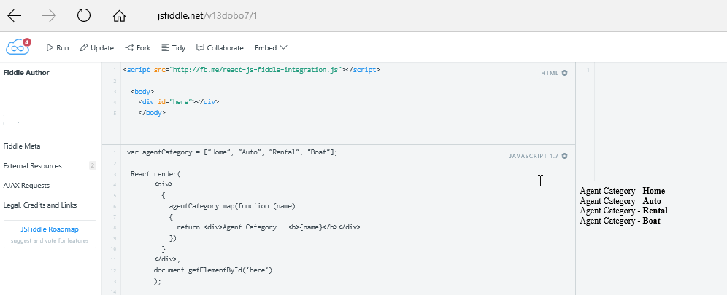

ReactJS Starter kit
We can download the ReactJS starter kit at:
http://reactjs.com
We can then click on the “Download React” button.
We can then click on the “Download Starter Kit”.
We will now have a ZIP file in our download folder.
We should now unzip the file and then copy the React directory to a location of our choice.

JSX
JSX stands for JavaScript XML. It is an XML like syntax for constructing markup within React components. IT should be noted that React does not have to be coded using JSX, we can simply use JavaScript. JSX is a preprocessor step that adds XML syntax to JavaScript.
Just like XML, JSX tags have a tag name, attributes, and children. If an attribute value is enclosed in quotes, the value is a string. Otherwise, wrap the value in braces and the value is the enclosed JavaScript expression.
In code we can use a script tag with the type "text/babel” attribute.

Babel
In JSX code we can also use a script tag with the type "text/babel” attribute. This means that we are coding using JSX (JavaScript with XML on it) inside it. We can think of JSX coding as sugar created to make it more "intuitive" to build XML (HTML in this case) components in JavaScript code. ReactJS makes use of JSX as an abstraction layer over the composition methods used to create and define UI elements.
The problem is that JSX is not a globally accepted standard and is not supported by all browsers. In order to turn our JSX into the standard vanilla JavaScript that can be understood by browsers we must us a third party "compiler" library. This is exactly what BABEL will do.
BABEL is a JavaScript compiler we can import using the "browser.min.js" file which will enable our code to be compiled, or more accurately the code inside the "text/babel" script tags will be compiled to vanilla JavaScript.

For these exercises you can use:
- Notepad++, Google Chrome, the ReactJS Starter kit and the Babel JSX compiler

Exercise One – Basic Component returning HTML
This basic HTML5 code will introduce you to the requirements for a web page in HTML5 which includes a basic ReactJS component.

- Open you text editor.
- Click on the File menu.
- Choose New.
- Click on the File menu.
- Choose Save As.
- Choose the location where you wish to save the file.
- In the text box to the right of the File name label enter the name of the HTML file you wish to create – ReactJSV1.
- Choose Hyper Text Markup Language file from the drop down list to the right of the Save as type label.
- Click the Save button.
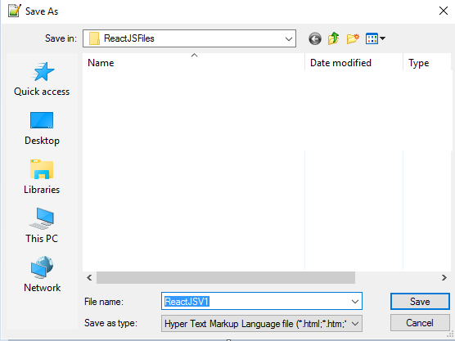
Save location
File name
Choose HTML option

- Make sure the ReactJSV1.html file is open in the text editor.
- Amend the code as shown below:

<!DOCTYPE html>
<html>
<head>
<meta charset="UTF-8" />
<title>Gerry Byrne - ReactJS Tutorials</title>
Use files from a Content Development Network (CDN)
<script src="https://cdnjs.cloudflare.com/ajax/libs/react/0.14.0/react.js"></script>
<script src="https://cdnjs.cloudflare.com/ajax/libs/react/0.14.0/react-dom.js"></script>
<script src="https://cdnjs.cloudflare.com/ajax/libs/react/0.13.3/JSXTransformer.js"></script>
<script src="https://cdnjs.cloudflare.com/ajax/libs/babel-core/5.8.24/browser.min.js"></script>
</head>
Specify a div with an id. We will use this later to display the contents of the ReactJS component
<body>
<div id="contentgoeshere"></div>
Create a component using createClass. Component is called FirstReactJSProgram
<script type="text/babel">
var FirstReactJSProgram = React.createClass({
render: function() {
return (
<h1>I am returning these details - <b>Gerry Byrne:ReactJS Tutorials</b></h1>
);
}
});
ReactDOM.render(<FirstReactJSProgram />, document.getElementById('contentgoeshere'));
</script>
</body>
</html>
This is the HTML to be returned
Tell ReactDOM to render the component and display it at the given location.

- Click on the Run menu.
- Choose Launch in Chrome.
The browser window will appear with the following web page displayed:
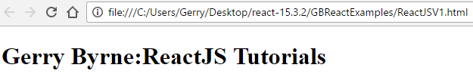
JSX code

Code Analysis
- The DOCTYPE declaration defines the document type as HTML
  - <!DOCTYPE html>
- The html tag lets us define the language we are using is we want to
  - <html lang="en">
- The head tag indicates the start of a heading area on our web page
  - <head>
- The end head tag indicates the end of a heading area on our web page
- The body tag indicates the start of a body area on our web page
  - <body>
- There is no text between <div> and </div> but we could use this area to display data if we had an id for the div
- Our div has an id of componentgoes here, so we will be able to refer to it later
<div id="componentgoeshere"></div>
- The script
<script src="https://cdnjs.cloudflare.com/ajax/libs/react/0.14.0/react.js"></script>
Tells the file to get the react.js file from a CDN.
- The script
<script src="https://cdnjs.cloudflare.com/ajax/libs/react/0.14.0/react-dom.js"></script>
Tells the file to get the react-dom.js file from a CDN.
Prior to v0.14, all functionality for ReactDOM was part of React. Since then React and ReactDOM have been split into two different libraries. ReactDOM is the connection between React and the DOM and we generally only use it to with the statement - ReactDOM.render(). We will use React to define and create our elements, React will be the main part of all our React applications.

- The script
<script src="https://cdnjs.cloudflare.com/ajax/libs/babel-core/5.8.24/browser.min.js"></script>
Tells the file to get the compiler file from a CDN.
- The end body tag indicates the end of a body area on our web page
  - </body>
- The end html tag indicates the end of a html code (page)
  - <\html lang>
- The compiler we use will understand which scripts hold the JSX when they see the
  - <script type=”text/babel” >
- The JSX creates a component called FirstReactJSProgram. A component is really just a class. A class that can only return one ‘piece’ of HTML code. To return the HTML React will render it using a function. So the code for this is:
var FirstReactJSProgram = React.createClass({
render: function() {
return (
<h1><b>Gerry Byrne:ReactJS Tutorials</b></h1>
);
}
});
- Now we will need to call this function and display the returned HTML code at a specific location in our HTML page. So the code for this is:
React.render(<FirstReactJSProgram />, document.getElementById('contentgoeshere'));

JSX
With our code we have written JSX because it is the new way to write vanilla JavaScript. So we might wonder what would we have to do to write the same JSX code in vanilla JavaScript. The answer is shown in the vanilla JavaScript code below:
Example - simple example
JSX | Vanilla JavaScript
var FirstReactJSProgram = React.createClass({  render: function() {  return (  <h1><b>Gerry Byrne:ReactJS Tutorials</b></h1>  );  }  }); | var FirstReactJSProgram = React.createClass({  displayName: "FirstReactJSProgram",  render: function render() {  return React.createElement(  "h1",  null,  React.createElement(  "b",  null,  "Gerry Byrne:ReactJS Tutorials"  )  );  }  });

We can see that we get a line of code that creates a React element. Code written with JSX will be converted to use Reacte.creatElement(). The creatElement() methods takes in 3 parameters:
- the type h1 in this case, the heading size.
The type argument can be either a tag name string (such as 'div' or 'span'), or a React component type (a class or a function).

- the props null in this case (more of this later).
The props parameter is a JavaScript object passed from a parent element to a child element. It can be an object containing attributes/props and values. When we say null it means we are not passing any props to that component.

- the children in this case another React create element which takes 3 parameters
Children can be null, a string that gets turned into a text node, an instance of React.createClass() or React.createElement().

More complicated example – JSX is relaatively simple but the vanilla JavaScript is much more complex and not really what we would like to type in.

Example - more intricate example
JSX | Vanilla JavaScript
const App = function(){  return  <ol>  <li>Gerry</li>  <li>David</li>  <li>Dwyer</li>  </ol>  } | var App = function App() {  return;  React.createElement(  "ol",  null,  React.createElement(  "li",  null,  "Gerry"  ),  React.createElement(  "li",  null,  "David"  ),  React.createElement(  "li",  null,  "Dwyer"  )  );  };

JSX Examples
Example One
ReactDOM.render(
React.createElement('div', {}, 'Hello, world!'),
document.body
);

Example Two
// Create React element
var elementLiOne = React.createElement('li', {id:'li1'}, ‘Gerry Byrne’),
elementLiTwo= React.createElement('li', {id:'li1'}, ‘David Wilson’),

Example Three
// Create React element
React.createElement("div",
{
id: "greeting-container",
className: "container"
},
React.createElement(Greeting, {name: "World"})
)

Example Four
var MyComponent = function MyComponent(props) {
return React.createElement(
"div",
null,
"Happy learning, ",
props.name
);
};

ReactDOM.render(React.createElement(MyComponent, { name: "Gerry Byrne" }), app);

Lab One – Basic Component returning HTML
Create a HTML page with a ReactJS component that says “This is a Bootstrap Comment Box”.

- Open you text editor.
- Click on the File menu.
- Choose New.
- Click on the File menu.
- Choose Save As.
- Choose the location where you wish to save the file.
- In the text box to the right of the File name label enter the name of the HTML file you wish to create – ReactJSLabV1.
- Choose Hyper Text Markup Language file from the drop down list to the right of the Save as type label.
- Click the Save button.
- Make sure the ReactJSLabV1.html file is open in the text editor.
- Amend the code as shown below:

<!DOCTYPE html>
<html>
<head>
<meta charset="UTF-8" />
<title>Gerry Byrne - ReactJS Tutorials</title>
<script src="https://cdnjs.cloudflare.com/ajax/libs/react/0.14.0/react.js"></script>
<script src="https://cdnjs.cloudflare.com/ajax/libs/react/0.14.0/react-dom.js"></script>
<script src="https://cdnjs.cloudflare.com/ajax/libs/react/0.13.3/JSXTransformer.js"></script>
<script src="https://cdnjs.cloudflare.com/ajax/libs/babel-core/5.8.24/browser.min.js"></script>
<link rel="stylesheet" href="https://maxcdn.bootstrapcdn.com/bootstrap/3.3.7/css/bootstrap.min.css">
</head>
<body>
<div class="container">
<div class="form-group">
<label for="comment">Comment:</label>
<textarea class="form-control" rows="5" id="comment">
</textarea>
</div>
<div id="contentgoeshere">
</div>
</div>
<script type="text/babel">
var CommentBox = React.createClass({
render: function() {
return (
<div>
<b>This is a Bootstrap Comment Box</b>
</div>
);
}
});
ReactDOM.render(<CommentBox />,document.getElementById('contentgoeshere')
);
</script>
</body>
</html>

- Click on the Run menu.
- Choose Launch in Chrome.

The browser window will appear with the following web page displayed:
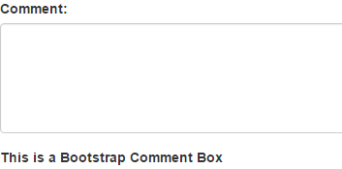
JSX code shown here

Exercise Two – Basic Component returning HTML
This basic HTML5 code will introduce you to the requirements for a web page in HTML5 which includes multiple components.

- Open you text editor.
- Click on the File menu.
- Choose New.
- Click on the File menu.
- Choose Save As.
- Choose the location where you wish to save the file.
- In the text box to the right of the File name label enter the name of the HTML file you wish to create – ReactJSV2.
- Choose Hyper Text Markup Language file from the drop down list to the right of the Save as type label.
- Click the Save button.
Save location
File name
Choose HTML option

- Make sure the ReactJSV2.html file is open in the text editor.
- Amend the code or copy and paste the code from the last example and amend it as shown below:

<!DOCTYPE html>
<html>
<head>
<meta charset="UTF-8" />
<title>Gerry Byrne - ReactJS Tutorials</title>
<script src="https://cdnjs.cloudflare.com/ajax/libs/react/0.14.0/react.js"></script>
<script src="https://cdnjs.cloudflare.com/ajax/libs/react/0.14.0/react-dom.js"></script>
<script src="https://cdnjs.cloudflare.com/ajax/libs/react/0.13.3/JSXTransformer.js"></script>
<script src="https://cdnjs.cloudflare.com/ajax/libs/babel-core/5.8.24/browser.min.js"></script>
</head>
<body>
<div id="contentgoeshere"></div>
<script type="text/babel">
var SecondReactJSProgram = React.createClass({
render: function() {
return (
<div>
<h1>
<b>Gerry Byrne:ReactJS Tutorials</b>
</h1>
<h2>
<b>David Wilson:ReactJS Tutorials</b>
</h2>
</div>
);
}
});
ReactDOM.render(<SecondReactJSProgram />, document.getElementById('contentgoeshere'));
</script>
</body>
</html>

- Click on the Run menu.
- Choose Launch in Chrome.
The browser window will appear with the following web page displayed:

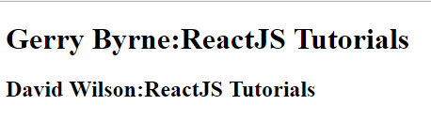
JSX code

Exercise Three – Multiples components and properties
This HTML5 code will introduce you to the requirements for a web page in HTML5 which includes multiple components and their properties.

- Open you text editor.
- Click on the File menu.
- Choose New.
- Click on the File menu.
- Choose Save As.
- Choose the location where you wish to save the file.
- In the text box to the right of the File name label enter the name of the HTML file you wish to create – ReactJSV3.
- Choose Hyper Text Markup Language file from the drop down list to the right of the Save as type label.
- Click the Save button.
Save location
File name
Choose HTML option

- Make sure the ReactJSV3.html file is open in the text editor.
- Amend the code or copy and paste the code from the last example and amend it as shown below:

<!DOCTYPE html>
<html>
<head>
<meta charset="UTF-8" />
<title>Gerry Byrne - ReactJS Tutorials</title>
<script src="https://cdnjs.cloudflare.com/ajax/libs/react/0.14.0/react.js"></script>
<script src="https://cdnjs.cloudflare.com/ajax/libs/react/0.14.0/react-dom.js"></script>
<script src="https://cdnjs.cloudflare.com/ajax/libs/react/0.13.3/JSXTransformer.js"></script>
<script src="https://cdnjs.cloudflare.com/ajax/libs/babel-core/5.8.24/browser.min.js"></script>
</head>
<body>
<div id="contentgoeshere"></div>
<script type="text/babel">
var SecondReactJSProgram = React.createClass({
render: function() {
return (
<div>
<h1>
<b>Gerry Byrne:ReactJS Tutorials</b>
</h1>
<h2>
<b>David Wilson:ReactJS Tutorials</b>
</h2>
</div>
);
}
});
ReactDOM.render(<SecondReactJSProgram />, document.getElementById('contentgoeshere'));
</script>
</body>
</html>
Only one tag can go here
- Click on the Run menu.
- Choose Launch in Chrome.
The browser window will appear with the following web page displayed:

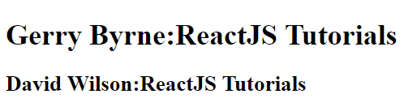

- Amend the code to add two or more tags inside the render method as shown below:

<script type="text/babel">
var SecondReactJSProgram = React.createClass({
render: function() {
return (
<div>
<h1>
<b>Gerry Byrne:ReactJS Tutorials</b>
</h1>
<h2>
<b>David Wilson:ReactJS Tutorials</b>
</h2>
</div>
);
}
});
ReactDOM.render(<SecondReactJSProgram/>, <SecondReactJSProgram/>, <SecondReactJSProgram/>, document.getElementById('contentgoeshere'));
</script>
</body>
</html>
Including multiple tags is not allowed – not data will appear on the HTML page

- Click on the Run menu.
- Choose Launch in Chrome.
The browser window will appear with a web page displayed with no data:
- Press the F12 function key to enter the developer tools.

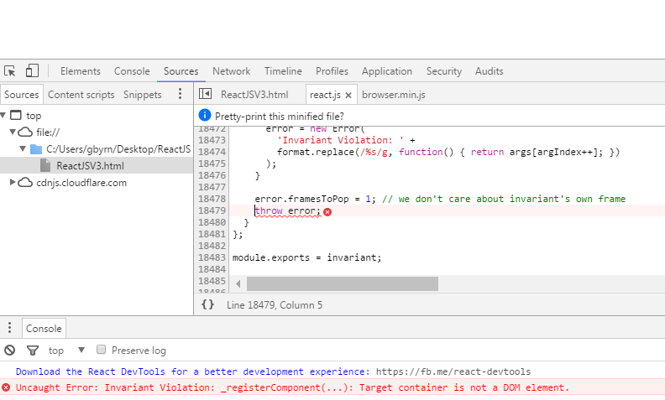
This is the blank web page. We have also entered the Developer Tools.

We can see that there is an error and we know it is because we cannot have multiple tags in this position in the render method.

Like the last exercise where we said that we can only return one HTML tag unless we wrap it in a tag like >div> or <span> etc. we could do the same here. So let us try this change.

- Amend the code to add a div tag to enclose the multiple tags as shown below:

ReactDOM.render(
<div>
<SecondReactJSProgram/>
<SecondReactJSProgram/>
<SecondReactJSProgram/>
</div>,
document.getElementById('contentgoeshere'));
</script>
</body>
</html>
Wrap the multiple tags inside a tag element

- Click on the Run menu.
- Choose Launch in Chrome.
The browser window will appear with the following web page displayed:
All tags inside the <div> are displayed

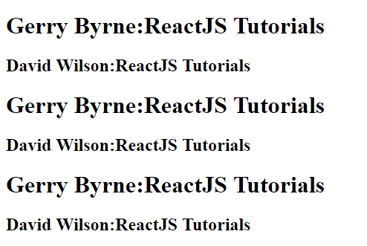

Exercise Four – Multiples components and properties (props)
This HTML5 code will introduce you to the requirements for a web page in HTML5 which includes multiple components and their properties.

- Open you text editor.
- Click on the File menu.
- Choose New.
- Click on the File menu.
- Choose Save As.
- Choose the location where you wish to save the file.
- In the text box to the right of the File name label enter the name of the HTML file you wish to create – ReactJSV4.
- Choose Hyper Text Markup Language file from the drop down list to the right of the Save as type label.
- Click the Save button.
Save location
File name
Choose HTML option

- Make sure the ReactJSV4.html file is open in the text editor.
- Amend the code or copy and paste the code from the last example and amend it as shown below:

<!DOCTYPE html>
<html>
<head>
<meta charset="UTF-8" />
<title>Gerry Byrne - ReactJS Tutorials</title>
<script src="https://cdnjs.cloudflare.com/ajax/libs/react/0.14.0/react.js"></script>
<script src="https://cdnjs.cloudflare.com/ajax/libs/react/0.14.0/react-dom.js"></script>
<script src="https://cdnjs.cloudflare.com/ajax/libs/react/0.13.3/JSXTransformer.js"></script>
<script src="https://cdnjs.cloudflare.com/ajax/libs/babel-core/5.8.24/browser.min.js"></script>
</head>
<body>
<div id="contentgoeshere"></div>
<script type="text/babel">
var NameAndCourseDetails = React.createClass({
render: function() {
return (
<div>
</div>
);
}
});
ReactDOM.render(
<div>
<NameAndCourseDetails lecturer="Gerry Byrne" course="ReactJS" />
<NameAndCourseDetails lecturer="David Wilson" course="Angular 2" />
<NameAndCourseDetails lecturer="Dwyer Gorman" course="Emotional Intelligence" />
<NameAndCourseDetails lecturer="Gerry Byrne" coursed="JavaScript" />
</div>,
document.getElementById('contentgoeshere'));
</script>
</body>
</html>
Two properties – lecturer and coursedetails

Now that we have added the properties (attributes) to the tag we need to be able to call them in the render method. To do this we use this.props syntax and add to the end the name of the property we wish to use. So to use the:
- lecturer property we have the syntax this.props.lecturer
- course property we have the syntax this.props.course

- Amend the code as shown below:
<body>
<div id="contentgoeshere"></div>
<script type="text/babel">
var NameAndCourseDetails = React.createClass({
render: function() {
return (
<div>
<h2>{this.props.lecturer} manages the course - {this.props.course}</h2>
</div>
);
}
});
ReactDOM.render(
<div>
<NameAndCourseDetails lecturer="Gerry Byrne" course="ReactJS" />
<NameAndCourseDetails lecturer="David Wilson" course="Angular 2" />
<NameAndCourseDetails lecturer="Dwyer Gorman" course="Emotional Intelligence" />
<NameAndCourseDetails lecturer="Gerry Byrne" course="JavaScript" />
</div>,
document.getElementById('contentgoeshere'));
</script>
</body>
</html>
Use the properties in the HTML tag

- Click on the Run menu.
- Choose Launch in Chrome.
The browser window will appear with the following web page displayed:
Properties shown for each part inside the div of the React.render

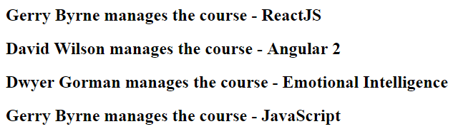

So we are effectively customising our component.

Exercise Five – Events
This HTML5 code will introduce you to the requirements for a web page in HTML5 that includes event handling.

- Open you text editor.
- Click on the File menu.
- Choose New.
- Click on the File menu.
- Choose Save As.
- Choose the location where you wish to save the file.
- In the text box to the right of the File name label enter the name of the HTML file you wish to create – ReactJSV5.
- Choose Hyper Text Markup Language file from the drop down list to the right of the Save as type label.
- Click the Save button.
Save location
File name
Choose HTML option

- Make sure the ReactJSV5.html file is open in the text editor.
- Amend the code or copy and paste the code from the last example and amend it as shown below:

<!DOCTYPE html>
<html>
<head>
<meta charset="UTF-8" />
<title>Gerry Byrne - ReactJS Tutorials</title>
<script src="https://cdnjs.cloudflare.com/ajax/libs/react/0.13.3/react.js"></script>
<script src="https://cdnjs.cloudflare.com/ajax/libs/babel-core/5.8.24/browser.min.js"></script>
</head>
<body>
<div id="contentgoeshere"></div>
<script type="text/babel">
var NameAndCourseDetails = React.createClass({
render: function() {
return (
<div>
<h2>{this.props.lecturer} manages the course - {this.props.course}</h2>
Add two buttons inside a div
<div>
<button>UPDATE</button>
<button>REMOVE</button>
</div>
</div>
);
}
});

Now we will create two functions that will be associated with the two buttons. The functions will be update and remove.

- Amend the code as shown below:
<body>
<div id="contentgoeshere"></div>
<script type="text/babel">
var NameAndCourseDetails = React.createClass({
Two functions added

update: function()
{
alert("Add business logic to the update function");
},
remove: function()
{
alert("Add business logic to the remove function");
},
render: function() {
return (
<div>
<h2>{this.props.lecturer} manages the course - {this.props.course}</h2>
<div>
<button>UPDATE</button>
<button>REMOVE</button>
</div>
</div>
);
}
});

- Click on the Run menu.
- Choose Launch in Chrome.
The browser window will appear with the following web page displayed:

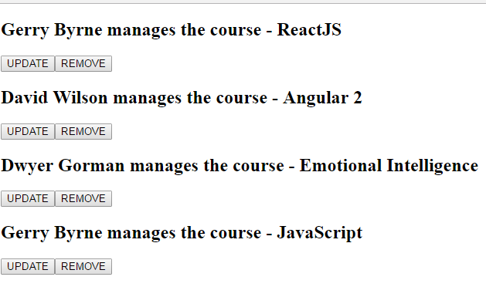

- Click on the Update or Remove.

Nothing will happen as we have not attached any event to the buttons and have not therefore connect button events to the functions we created.

- Amend the code as shown below:
return (
<div>
<h2>{this.props.lecturer} manages the course - {this.props.course}</h2>
<div>
<button onClick={this.update}>UPDATE</button>
<button onClick={this.remove}>REMOVE</button>
</div>
</div>
);
}
});

- Click on the Run menu.
- Choose Launch in Chrome.
The browser window will appear with the following web page displayed:

- Click on any Update button.
The alert will appear.
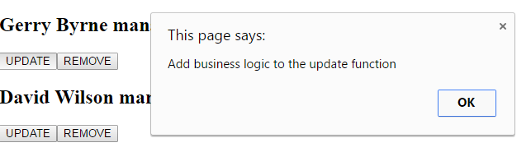
- Click on the OK button.
- Click on any Remove button.
The alert will appear.
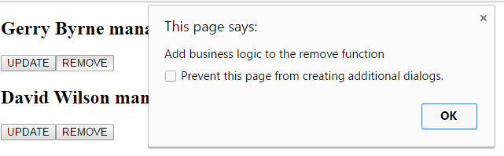

Exercise Six – State
In this example we will look at the use of State. When we have used a component in the previous examples we have used components that have had props (properties). A component can be customised with:
- Properties we use properties if the value is fixed (like a constant)
- State we use state if the value is dynamic

Think about a checkbox which can have its text changed when it is selected or deselected. The component should therefore use state rather than properties.

- Open you text editor.
- Click on the File menu.
- Choose New.
- Click on the File menu.
- Choose Save As.
- Choose the location where you wish to save the file.
- In the text box to the right of the File name label enter the name of the HTML file you wish to create – ReactJSV6.
- Choose Hyper Text Markup Language file from the drop-down list to the right of the Save as type label.
- Click the Save button.
Save location
File name
Choose HTML option

- Make sure the ReactJSV6.html file is open in the text editor.
- Amend the code or copy and paste the code from the last example and amend it as shown below:

<!DOCTYPE html>
<html>
<head>
<meta charset="UTF-8" />
<title>Gerry Byrne - ReactJS Tutorials</title>
<script src="https://cdnjs.cloudflare.com/ajax/libs/react/0.13.3/react.js"></script>
<script src="https://cdnjs.cloudflare.com/ajax/libs/babel-core/5.8.24/browser.min.js"></script>
</head>
<body>
<div id="contentgoeshere"></div>
<script type="text/babel">
var CheckBox = React.createClass({
Use the getInitialstate function to set checked to true
getInitialState:function()
{
return{checked:true}
},
handleChecked:function(){
Create a function to handle the checking and unchecking of the checkbox. Set the state to the opposite of its current state.
this.setState({checked:!this.state.checked})
},
render:function(){
var message;
if(this.state.checked)
{
message = 'checked';
}
else
{
message = 'not checked';
}
return (
Use the onChange event
<div>
<input type='checkbox' onChange={this.handleChecked} defaultChecked = {this.state.checked}/>
<h3>Home Insurance is {message}</h3>
</div>
);
}
});
Render the CheckBox class at the specified tag

React.render(<CheckBox/>,document.getElementById('contentgoeshere'));
</script>
</body>
</html>

- Click on the Run menu.
- Choose Launch in Chrome.
The browser window will appear with the following web page displayed:

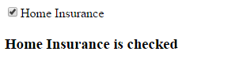

- Click on the checkbox.

The text automatically changes since it is controlled by state rather than prop. The browser window will appear with the following web page displayed:

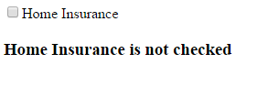

Exercise Seven – Adding state to components
We will revisit the example we did earlier and make some improvements. We will add functionality to the Update button and add a Save button.

- Open you text editor.
- Click on the File menu.
- Choose New.
- Click on the File menu.
- Choose Save As.
- Choose the location where you wish to save the file.
- In the text box to the right of the File name label enter the name of the HTML file you wish to create – ReactJSV7.
- Choose Hyper Text Markup Language file from the drop down list to the right of the Save as type label.
- Click the Save button.
Save location
File name
Choose HTML option

- Make sure the ReactJSV7.html file is open in the text editor.
- Amend the code or copy and paste the code from example 5 and amend it as shown below to add the constructor function:

<!DOCTYPE html>
<html>
<head>
<meta charset="UTF-8" />
<title>Gerry Byrne and David Wilson - ReactJS Tutorials</title>
<script src="https://cdnjs.cloudflare.com/ajax/libs/react/0.14.0/react.js"></script>
<script src="https://cdnjs.cloudflare.com/ajax/libs/react/0.14.0/react-dom.js"></script>
<script src="https://cdnjs.cloudflare.com/ajax/libs/react/0.13.3/JSXTransformer.js"></script>
<script src="https://cdnjs.cloudflare.com/ajax/libs/jquery/2.1.1/jquery.min.js"></script>
<script src="https://cdnjs.cloudflare.com/ajax/libs/babel-core/5.8.24/browser.min.js"></script>
</head>

<body>
<div id="contentgoeshere"></div>
<script type="text/babel">

class NameAndCourseDetails extends React.Component
{
constructor(props)
{
super(props)
this.update = this.update.bind(this)
this.remove = this.remove.bind(this)
this.save = this.save.bind(this)
this.renderNormal = this.renderNormal.bind(this)
this.renderFrom = this.renderForm.bind(this)
this.state= {editing:false}
}

- Amend the code as shown below to amend the update function:

update()
{
this.setState({editing:true});
}

- Amend the code as shown below to add the remove and save functions:

update()
{
this.setState({editing:true});
}

remove()
{
alert("Add business logic to the remove function");
}

save()
{
this.setState({editing:false});
}

- Amend the code as shown below to amend the render function to reflect the two states:

save()
{
this.setState({editing:false});
}

renderNormal()
{
return (
<div>
<div><textarea defaultValue = {this.props.lecturer}></textarea></div> <button onClick={this.update}>UPDATE</button>
button onClick={this.remove}>REMOVE</button>
</div>
);
}

renderForm() {
return (
<div>
<textarea defaultValue = {this.props.lecturer}></textarea>
<button onClick={this.save}>SAVE</button>
</div>
);
}

- Amend the code as shown below to call the two new functions from the render function which is the function we always use first:

renderForm() {
return (
<div>
<textarea defaultValue = {this.props.lecturer}></textarea>
<button onClick={this.save}>SAVE</button>
</div>
);
}

render() {
if(this.state.editing)
{
return this.renderForm();
}
else
{
return this.renderNormal();
}
}
};

ReactDOM.render(
<div>
<NameAndCourseDetails lecturer="Gerry Byrne" course="ReactJS" />
<NameAndCourseDetails lecturer="David Wilson" course="Angular 2" />
<NameAndCourseDetails lecturer="Dwyer Gorman" course="Emotional Intelligence" />
<NameAndCourseDetails lecturer="Gerry Byrne" course="JavaScript" />
</div>,
document.getElementById('contentgoeshere'));
</script>
</body>
</html>

- Click on the Run menu.
- Choose Launch in Chrome.
The browser window will appear with the following web page displayed:
JSX code

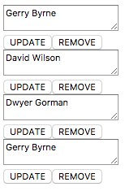
- Click on the Update button.
- Amend the text in the text area.
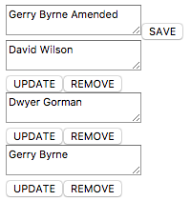

- Click on the Save button.

We will be returned to the normal screen but our text will not have been saved as we have not added the business logic for this aspect of the application.

Exercise Eight – Using Refs
We will revisit the example we did earlier and make some improvements. We will add functionality to the Save button so the text is updated. Initially we will write the value to the console.

- Open you text editor.
- Click on the File menu.
- Choose New.
- Click on the File menu.
- Choose Save As.
- Choose the location where you wish to save the file.
- In the text box to the right of the File name label enter the name of the HTML file you wish to create – ReactJSV8.
- Choose Hyper Text Markup Language file from the drop-down list to the right of the Save as type label.
- Click the Save button.
Save location
File name
Choose HTML option

- Make sure the ReactJSV8.html file is open in the text editor.
- Amend the code or copy and paste the code from the last example and amend it as shown below to add a ref to the textarea. A reference is like an id for the purposes of this example.

<!DOCTYPE html>
<html>
<head>
<meta charset="UTF-8" />
<title>Gerry Byrne - ReactJS Tutorials</title>
<script src="https://cdnjs.cloudflare.com/ajax/libs/react/0.13.3/react.js"></script>
<script src="https://cdnjs.cloudflare.com/ajax/libs/babel-core/5.8.24/browser.min.js"></script>
</head>
<body>
<div id="contentgoeshere"></div>
<script type="text/babel">
var NameAndCourseDetails = React.createClass({

getInitialState:function()
{
return {editing:false}
},
update: function()
{
this.setState({editing:true});
},
remove: function()
{
alert("Add business logic to the remove function");
},
save: function()
{
this.setState({editing:false});
},

renderNormal: function() {
return (
<div>
<div><textarea defaultValue = {this.props.lecturer}></textarea></div> <button onClick={this.update}>UPDATE</button>
<button onClick={this.remove}>REMOVE</button>
</div>
);
},
renderForm: function() {
return (
<div>
<textarea ref="newText" defaultValue = {this.props.lecturer}></textarea>
<button onClick={this.save}>SAVE</button>
</div>
);
},

render: function() {
if(this.state.editing)
{
return this.renderForm();
}
else
{
return this.renderNormal();
}
}
});

React.render(
<div>
<NameAndCourseDetails lecturer="Gerry Byrne" course="ReactJS" />
<NameAndCourseDetails lecturer="David Wilson" course="Angular 2" />
<NameAndCourseDetails lecturer="Dwyer Gorman" course="Emotional Intelligence" />
<NameAndCourseDetails lecturer="Gerry Byrne" course="JavaScript" />
</div>,
document.getElementById('contentgoeshere'));
</script>
</body>
</html>

- Amend the code as shown below to amend the update function:

<!DOCTYPE html>
<html>
<head>
<meta charset="UTF-8" />
<title>Gerry Byrne - ReactJS Tutorials</title>
<script src="https://cdnjs.cloudflare.com/ajax/libs/react/0.13.3/react.js"></script>
<script src="https://cdnjs.cloudflare.com/ajax/libs/babel-core/5.8.24/browser.min.js"></script>
</head>
<body>
<div id="contentgoeshere"></div>
<script type="text/babel">
var NameAndCourseDetails = React.createClass({

getInitialState:function()
{
return {editing:false}
},
update: function()
{
this.setState({editing:true});
},
remove: function()
{
alert("Add business logic to the remove function");
},
save: function()
{
var val = React.findDOMNode(this.refs.newText).value;
console.log('The new text entered is - ' + val);
alert(val);
this.setState({editing:false});
},

renderNormal: function() {
return (
<div>
<div><textarea defaultValue = {this.props.lecturer}></textarea></div> <button onClick={this.update}>UPDATE</button>
<button onClick={this.remove}>REMOVE</button>
</div>
);
},

- Click on the Run menu.
- Choose Launch in Chrome.
The browser window will appear with the following web page displayed:
JSX code

- Click on the Update button.
- Amend the text in the text area.

- Click on the Save button.

We will be returned to the normal screen and the message with the new text will be displayed in the Console window and an Alert appears.

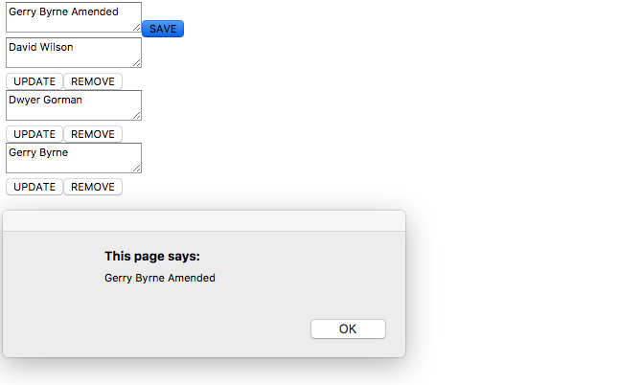

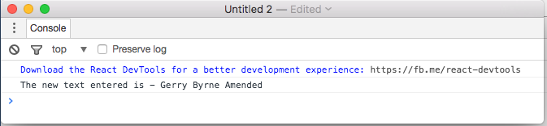

- Click the OK button of the Alert.

Exercise Nine – Using Multiple Child Components
We will revisit the example we did earlier and make some improvements. Currently we can sort of edit comments and we're going to be able to remove comments etc. later. Equally we have a set of independent comments, each comment is unaware that the other comments exist. This would mean that if we wanted to sort or rearrange the comments we would have a difficult time. We need to wrap the comments in a container so we can manage them properly.

The comments we see are really going to be in a container or on a board (the red box represents this) that means we can manage them.

- Open you text editor.
- Click on the File menu.
- Choose New.
- Click on the File menu.
- Choose Save As.
- Choose the location where you wish to save the file.
- In the text box to the right of the File name label enter the name of the HTML file you wish to create – ReactJSV9.
- Choose Hyper Text Markup Language file from the drop-down list to the right of the Save as type label.
- Click the Save button.
Save location
File name
Choose HTML option

- Make sure the ReactJSV9.html file is open in the text editor.
- Amend the code or copy and paste the code from the last example and amend it as shown below to add a ref to the textarea. A reference is like an id for the purposes of this example.

